Bahria University,

Karachi Campus

LAB EXPERIMENT NO.

**3**

LIST OF TASKS

|  |  |
| --- | --- |
| TASK NO | OBJECTIVE |
| **1** | **To take integer and display table of a number** |
|  |  |
|  |  |
|  |  |
|  |  |
|  |  |
|  |  |
|  |  |
|  |  |
|  |  |
|  |  |
|  |  |
|  |  |
|  |  |
|  |  |
|  |  |

Submitted On:

**3-Nov-21**

(Date: DD/MM/YY)

**Example**

**Simple looping**

**First method**

**Code**

in

sto 99

brp 04

br 10

brz 10

lda 99

out

in

sto 99

br 02

hlt

**Output**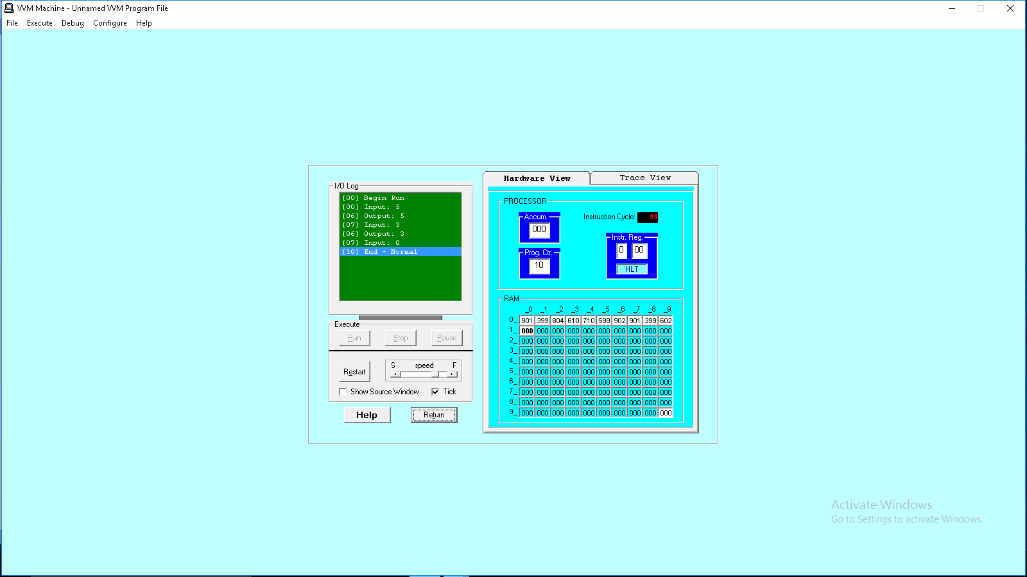

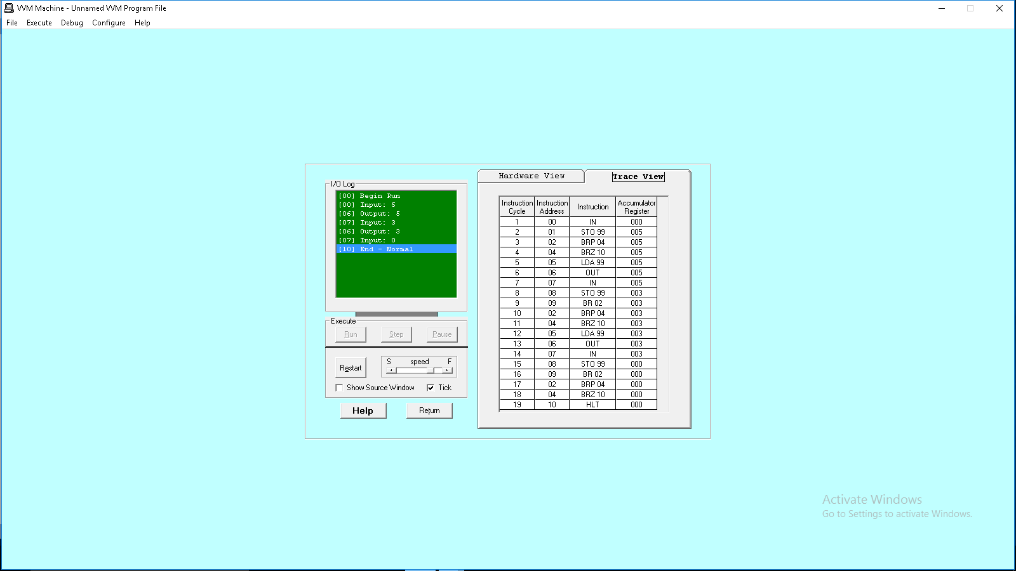

**Second Method**

**Code**

in

sto 99

brp 04

br 10

brz 10

lda 99

out

br 00

hlt  
  
**Output**

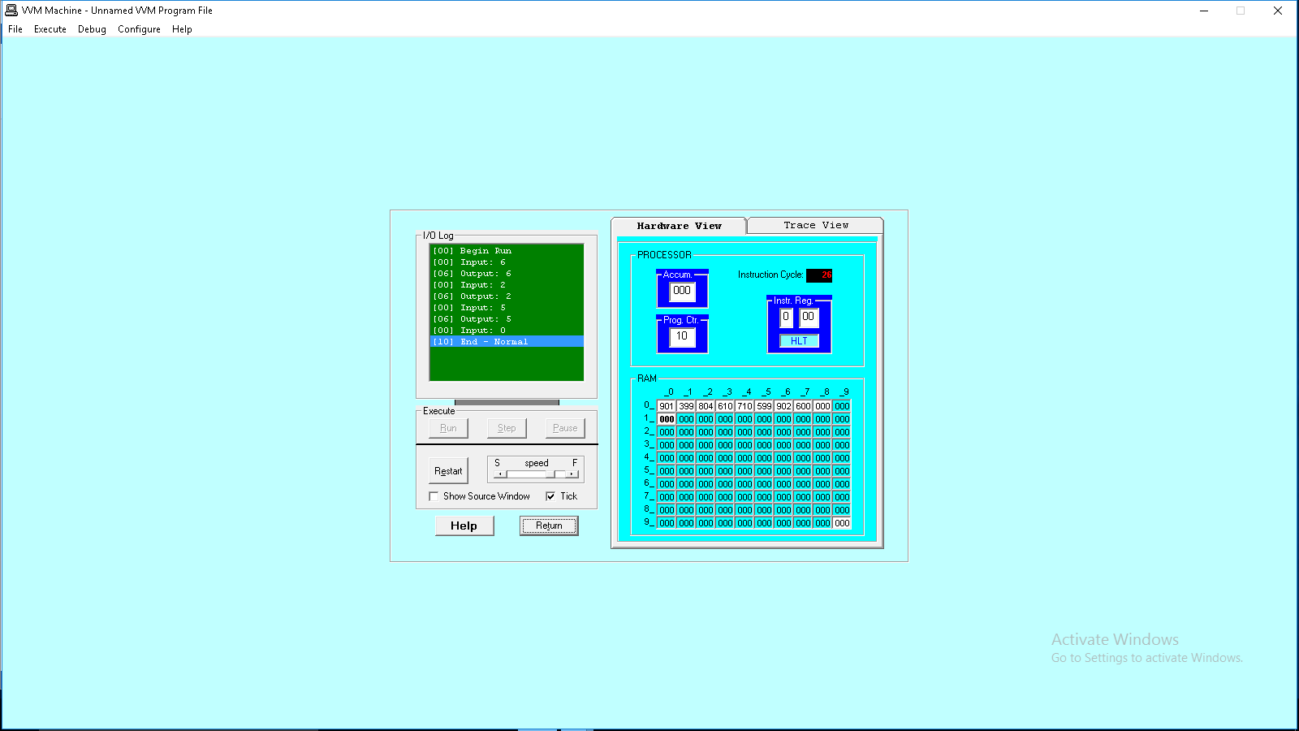

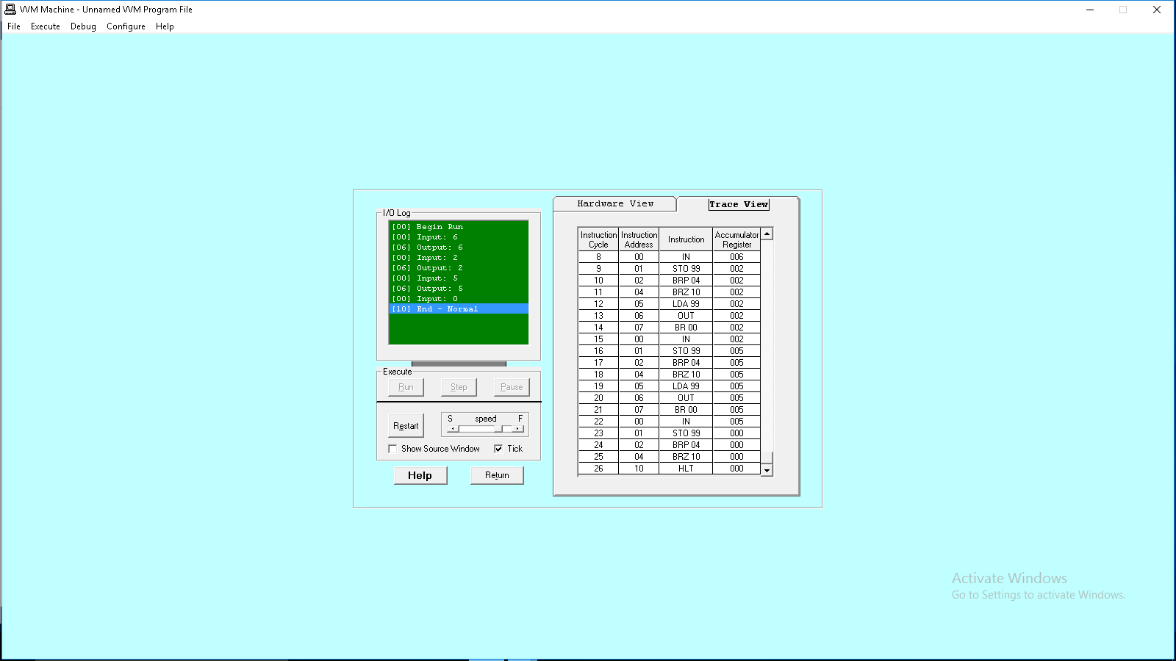

**Example**

**To print the square of a number**

**Code**

in

sto 99

lda 98

add 99

sto 98

lda 97

add 96

sto 97

sub 99

brz 11

br 02

lda 98

out

hlt Halt (end of program)

// Data used by program follows

*96 Resume loading at address 96

dat 001 Constant for counting

dat 000 Initial index value

dat 000 Initial sum

**Output  
**

**Task 1**

**To take an integer and display the table of a number**

**Code**

in

sto 91

lda 91

out

sto 96

lda 96

add 91

sto 96

lda 96

out

lda 97

sub 95

sto 97

brz 15

brp 05

hlt

*95

dat 001

dat 000

dat 009

dat 000

